**Size selective predation by three estuarine zooplanktivorous fish species**

Hayden T. Schilling1,2*, James A. Smith1,2, Jason D. Everett1,2,3, Daniel P. Harrison2,4,5, Iain M. Suthers1,2

1 Centre for Marine Science and Innovation, UNSW Sydney, NSW 2052, Australia

2 Sydney Institute of Marine Science, Mosman NSW 2088, Australia

3 School of Mathematics and Physics, The University of Queensland, St. Lucia, Queensland 4072, Australia

4 University of Sydney Institute of Marine Science, School of Geosciences, University of Sydney, NSW 2006, Australia

5 National Marine Science Centre, Southern Cross University, Coffs Harbour, NSW 2450, Australia

* Corresponding author. Email: [h.schilling@unsw.edu.au](mailto:h.schilling@unsw.edu.au)

Target Journal: Marine Freshwater Research

Date: 3/12/2021

Word Count: ~ XXX

**Running Title:** Size selective zooplanktivory

**Abstract:**

Zooplanktivorous fish are a key link between abundant zooplankton and higher trophic levels but the foraging behaviour of zooplanktivorous fish is not fully understood. Selective feeding behaviours have previously been observed in many species of planktivorous fish where targeting of certain species and sizes of zooplankton has been observed. However, why certain size classes of zooplankton are preferred remains unclear. Using optimal foraging theory, we assess the size selective feeding behaviour of three of the most common zooplanktivorous fish species in Sydney Harbour, Australia. By using a Laser Optical Plankton Counter to assess the size structure of zooplankton in the environment and comparing this to the size distribution of zooplankton in gut contents we show that the targeted prey size of the zooplanktivorous fish aligns with the prey size classes in the environment that contain the highest overall biomass. These prey sizes therefore represent the most efficient prey to target as the return on foraging effort is greatest. By incorporating this information on this key trophic link between zooplankton and fish, ecosystem models could better resolve the size dependant predation, particularly in size-based models.

Keywords: planktivory; Laser Optical Plankton Counter; Optimal Foraging Theory; *Atypichthys strigatus*; *Trachurus novaezelandiae*; *Scorpis lineolata*

**Introduction**

Predation transfers biomass from lower trophic levels to higher trophic levels in ecosystems. Optimal foraging theory is a broad framework that seeks to understand foraging behaviour, including predation. Underlying this theory is the assumption that an animal will make foraging decisions which will maximise the amount of energy ingested while minimising the energy used during feeding (Pyke *et al.* 1977). Although sometimes criticised for being too simplistic and not representative of the natural environment (Pierce and Ollason 1987), this theory continues to provide a useful framework for exploring foraging behaviour and has been used recently to make and test predictions about foraging for a range of taxa including marine mammals (Foo *et al.* 2016; Tyson *et al.* 2016), birds (Hernández-Pliego *et al.* 2017), lions (Barnardo *et al.* 2020) and fish (Thygesen *et al.* 2016).

Marine and aquatic ecosystems are strongly structured by size (Sheldon *et al.* 1972; Andersen *et al.* 2016; Hatton *et al.* 2021). By using size structured models, the predatory relationships between organisms can often be simplified. Size structured models use size classes as an alternative to individual species in ecosystem models (Andersen and Beyer 2006; Blanchard *et al.* 2017). This greatly reduces the number of links within a model compared to a traditional ecosystem model, and has been used successfully to investigate both ecological and fisheries management research questions (Blanchard *et al.* 2014; Heneghan *et al.* 2016). In marine ecosystems small prey tend to be highly abundant compared to larger prey yet they contain less biomass per individual and may be harder to detect compared to larger prey (Hansen *et al.* 2013). This presents marine predators with a choice, do they feed upon the abundant easy to catch prey or do they target larger prey?

Zooplanktivorous fish are a key trophic link between abundant zooplankton and larger predators. On coastal reefs, zooplankton support over 50 % of the fish communities biomass, with much of this flowing through small zooplanktivorous fish (Truong *et al.* 2017). The foraging strategy of zooplanktivorous fish presents an interesting test of optimal foraging theory. Zooplankton are highly abundant (often >1000 individuals m-3) and small zooplankton are often an order of magnitude more abundant than large zooplankton (Sheldon *et al.* 1972; Heneghan *et al.* 2016), meaning the chance of a zooplanktivorous fish encountering small prey is much greater than large prey. On the other hand, a large copepod can contain up to 15 times more biomass than a small copepod (Chisholm and Roff 1990), which may make large zooplankton a preferential prey source. This creates a situation where zooplanktivorous fish could feed randomly based upon encounter rates of zooplankton (commonly known as filter feeding), essentially eating mostly smaller zooplankton or they could target larger zooplankton (particulate feeding) if the trade off in terms of biomass return for energy used in searching for and capturing the larger prey is favourable. Assuming that consuming the greatest amount of biomass for the least effort is the goal of zooplanktivorous fish, then perhaps their feeding strategy is mediated not by the abundance of different prey but by the biomass of each prey type in the environment. It is plausible that they would target the prey type with the highest biomass in the environment, rather than abundance. Some species have been observed to switch between filter feeding and particulate feeding behaviours in response to changes in prey density (Jansen *et al.* 2019).

Prey selectivity of zooplankton by zooplanktivorous fish has previously been explored with a focus on mouth size and gill raker dimensions proving mixed results. While mouth size is important for small fish (<30 mm), fish are quickly capable of feeding upon almost all zooplankton and at larger fish sizes the limiting factor becomes handling time and capturing prey (Wanzenbock 1995). Similarly gill raker size has been shown to not be a limiting factor on the capture of small particles, although it may reduce the efficiency of capture leading to increased relative capture of larger particles (Langeland and Nøst 1995; Budy *et al.* 2005). Overall prey selectivity in zooplanktivorous fish is not simply driven by morphology but there is also active selection of different size prey, particularly for larger zooplanktivorous fish which have the ability to capture all sizes of prey and can significantly alter their own behaviour while foraging (Tanaka *et al.* 2006).

The goal of our study was to explore the foraging strategy of three the most common zooplanktivorous fish in Sydney Harbour. To investigate selective feeding we measured the size-structured zooplankton abundance and biomass in the environment over the summer period, and compared this with the size-structured diet of planktivorous fish collected over the same period. The specific aims were to: (1) examine the average size structured zooplankton abundance and biomass in Sydney Harbour over a 3 month period; (2) determine the prey size and diet composition of three planktivorous estuarine fish, and (3) compare the prey size of the gut contents with the size structure of zooplankton available in the water to quantify size selective predation.

**Methods**

*Zooplankton Sampling*

Zooplankton were sampled in the lower reach of Sydney Harbour between November 2013 and February 2014 (summer) at three sites (Site 1: -33.834 °, 151.278°, Site 2: -33.839°, 151.277°, Site 3: -33.849°, 151.266°), along the southern shore close to the mouth of the estuary and the dominant tidal flow. The total distance between sites was 2.1 km. All sites were sampled in the morning on ten days, during five ebb and five flood tides (sampled 2 - 3 h after the predicted high or low tide). At each site, three horizontal replicate plankton tows were done using a 40 cm diameter, 100 µm mesh net at 1 m depth. A mechanical flowmeter (Model 2030R, General Oceanics Inc., Miami, USA) was attached to the net to calculate the sampling volume. A detailed description of the Sydney Harbour ecosystem is available in Johnston *et al*. (2015).

The zooplankton size-distribution and biomass from all towed samples was determined using a laboratory based Laser Optical Plankton Counter (LOPC; Herman *et al.* 2004), coupled to a pump system (Moore and Suthers 2006). When a particle passed through the beam of the LOPC, the size of the shadow was detected and recorded as the corresponding equivalent spherical diameter (ESD) of the particle. The zooplankton was sorted into a size frequency distribution with 30 µm bins. Only particles between 300 and 3000 µm ESD were included as particles outside this size range were unlikely to be sampled accurately by the plankton net (Moore and Suthers 2006). A subsample of 300 particles from each tow from Sites 1 and 3 were identified to a coarse taxonomic resolution using a dissecting microscope and Bogorov tray to investigate composition. Zooplankton biomass was calculated by converting ESD values (µm) to biomass (Suthers *et al.* 2004) assuming the volume of a sphere and the density of water (*ρ* =109 mg m-3) using:

(1)

As the goal of this study was to investigate foraging behaviour of zooplanktivores rather than variation in the zooplankton community, all zooplankton samples were averaged together to provide a representative zooplankton snapshot over the whole sampling period. This aligns with the fish collection discussed below.

*Fish gut content sampling*

Over the same time period as the zooplankton sampling, three species of suspected zooplanktivorous fish were collected using by either unbaited hook-and-line or spearfishing from the study area. These species were observed to be the most abundant around our sampling sites and were confirmed to be some of the most abundant small fish in Sydney Harbour using data from fish surveys undertaken by the Reef Life Survey (Edgar and Stuart-Smith 2014). Individual *Atypichthys strigatus* (Günther, 1860, n = 17), *Trachurus novaezelandiae* (Richardson, 1843, n = 24) and *Scorpis lineolata* (Kner, 1865, n = 22) were placed on ice and later frozen until dietary analysis took place. Fish were collected throughout the sampling period, irrespective of tide, and within 500 m of the zooplankton sampling sites.

The gut contents of each fish were weighed and prey items identified to a coarse taxonomic resolution. The fullness and percentage (by volume) of plant matter, zooplankton and unidentifiable material was recorded for each gut. The size-distribution (ESD) of zooplankton in the gut contents was determined from the length and width of zooplankton, to compare with the size-distribution of zooplankton in the water column (the LOPC data). From each gut, a random sample of each zooplankton taxonomic group was photographed using a Leica M80 Microscope with Leica Application Suite v4.4 (Leica Microsystems GmbH, Wetzlar, Germany). ImageJ v1.48 (Schneider *et al.* 2012) was used to measure the length (*l*; mm) and width (*w*; mm) of each prey item in the photographs. Length and width measurements were converted into an ESD (µm) using:

$ESD=2\sqrt{\frac{l×w}{4}}×1000 µm$ (2)

To determine the size range of zooplankton having the highest incidence of consumption by estuarine planktivorous fish, the ESD measurements of identified prey within the fish guts were compiled into frequency histograms for each fish (30 µm bins; corresponding to those of the LOPC). The prey size distributions of all individuals from each species were then averaged to obtain an average prey size distribution for each species. The mean size distributions of prey from the three species were then averaged to create an overall average prey size distribution for zooplanktivorous fish in Sydney Harbour.

*Data Analysis*

All analysis was conducted using R v4.0.2 (R Core Team 2020). A split plot analysis of variance was used to test for differences in total zooplankton biomass between tides and sites, with tide and site as fixed factors and day as a random factor. It was a split-plot design because only one level of tide (ebb or flood) was sampled per day (the ‘plot’). The zooplankton biomass was log10 transformed to meet the assumptions of normality and homogeneity of variance. An analysis of similarity (ANOSIM) was used to test for differences in abundance of taxa found in the plankton tows from Sites 1 and 3.

To assess selective predation in our zooplanktivorous fish we utilised a simulation approach similar approach to Chappell and Smith (2016). We generated four null models of expected prey distributions under the assumption that non-selective feeding would result in prey size distributions reflecting the zooplankton distribution in the environment. There was one model for each species and a model for the average of all three species. Using the abundance (%) of each 30 µm ESD zooplankton size class in the water we created a simulated population of known size distribution. From this population we then drew 2,000 random samples of X prey items where X is represents the average number of prey items found in each species gut or the average of all three species for the average model. From these 2000 samples we generated a mean size frequency distribution with a 95% confidence interval. We then assessed size selective predation by comparing the observed predation rates for each size class to the null predictions. If a size class occurred in the fish guts more frequently than predicted by the null simulation, this suggests that this size class is disproportionately preyed upon. To calculate a conservative likelihood of this observed pattern being equivalent to the expectation based upon random feeding we calculated a conservative P-value using the 2000 random draw simulations described above. For each size class for each species, we calculated the proportion of times the predicted frequency fell within the observed 95 % confidence interval. Compared to traditional selectivity indices such as those of Chesson (1978), the simulation approach allows for robust analyses of low sample sizes and provides a benchmark of null selection to compare against (Chappell and Smith 2016).

**Results**

*Zooplankton Biomass*

A total of 86 plankton tows were analysed using the Laser Optical Plankton Counter (LOPC). Four samples, each from a different site or day, contained too much gelatinous material for accurate analysis so were excluded. The zooplankton biomass varied over an order of magnitude both between days and within days between sites. The smallest zooplankton biomass was recorded at Site 1 with 106.0 mg m-3 (25 November 2013), and the largest was 1722.2 mg m-3, at Site 3 (27 February 2014). The largest range in zooplankton biomass across the three sites on a single day was 1120.0 mg m-3 (27 February 2014). No significant difference in zooplankton biomass was found between ebb and flood tides (ANOVA: F*1,8* = 1.17, *p* = 0.31) but Site 3 contained significantly more zooplankton biomass than Site 1 across all tides (ANOVA: F*2,72* = 5.48, *p* < 0.01, Figure S1). No significant interaction was found between tide and site (ANOVA: F*2,72* = 0.83, *p* = 0.44).

Despite this variation in total biomass between samples, when the % biomass and abundances in each size class was investigated, consistent patterns were observed and we present an overall average zooplankton distribution which shows consistent declines in abundance with size and a peak in biomass between 495 and 705 µm ESD (Figure 1). Between sites there only were minor differences in the biomass % size distributions with site 3 having a lower percentage biomass compared to the other sites in the small bins (<375 µm ESD) and Site 1 having a slightly more even distribution of biomass (a lower peak between 495 and 705 µm ESD; Figure S1).

*Fish Diets*

A total of 4,140 prey items were identified in the guts of 17 *Atypichthys strigatus*, 22 *Scorpis lineolata* and 24 *Trachurus novazelandiae*.No guts were empty, although seven contained fewer than 10 identifiable prey items. *A. strigatus*, *T. novaezelandiae* and *S. lineolata* all consumed zooplankton. In *A. strigatus* and *T. novaezelandiae*, zooplankton comprised 100% of the identifiable gut contents. In *S. lineolata*,zooplankton comprised 40% with plant matter making up the other 60%. Copepods were the most abundant prey items for all species (Figure 2a). They were found in 97% of all guts (Figure 2b) and represent 64%, 66% and 41% of all prey items by count in *A. strigatus, S. lineolata* and *T. novaezelandiae* respectively. *A. strigatus* had the greatest average number of prey items in their guts (145.1 ± 21.4 SE) while *T. novaezelandiae* had the fewest (26.8 ± 4.4 SE; Table 1). *S. lineolata* was the only species to consume plant material, sand grains or barnacle cirri. *T. novaezelandiae* had the smallest species richness in its diet, containing eight prey types, compared to 13 and 14 prey types for *A. strigatus* and *S. lineolata* respectively.

*Selective predation*

1,997 prey items from gut contents were measured and converted to an equivalent spherical diameter to be comparable with the zooplankton measurements from the LOPC. The three species of fish showed a similar pattern of prey sizes in their guts (Figures 3 & 4). The smallest size class of prey was 270 - 300 µm ESD with only 0.07% (± 0.02 SD) of prey. This smallest size class was smaller than that resolved by the LOPC so was not included in comparisons with zooplankton in the environment. The largest size class containing prey was 3510 - 3540 µm ESD, containing only 0.02% (± 0.03 SD). The median prey size class was 570 - 600 µm ESD.

Strong evidence of size selective predation was found for all three species. When compared to the null model of expected diet proportions based upon the assumption of random feeding and the observed size structure in the environment, all species showed an under selection of prey in both small (< 485 µm ESD) and large (> 805 µm ESD) size classes (Figure 3; Table S1). This corresponded to strong evidence of an over selection of medium size particles (585 -735 µm ESD) in *A. strigatus* and *S. lineolate*. There was only weak evidence of positive selectivity in *T. novaezelandiae* due to the low average number of prey items within their guts creating large 95% confidence intervals (Figure 3, Table S1).

When compared to the null model of expected diet proportions calculated using the biomass of each size class in the environment rather than the abundance, the evidence for size selective feeding was reduced and our observed prey sizes aligned more closely with expectation (Figure 4). While there continued to be some evidence of under selection at small and large prey sizes, there was vastly reduced evidence of positive selectivity occurring in any size class (Table S1). The peak in observed prey size corresponded to the peak in size classes which contain the most biomass in the environment.

**Discussion**

This study shows strong evidence of size selective predation occurring in three estuarine zooplanktivorous fish. By comparing the observed prey size compositions with expected prey size compositions based upon feeding relative to environmental abundance and biomass in each size class, we propose that size selective predation is driven by the increased amount of biomass available in the environment for preferred size classes relative to the other size classes. Our finding supports the theory of optimal foraging theory. As the goal of foraging is to consume the greatest biomass for the least effort, the size classes with the greatest biomass in them represent the most ‘profitable’ food sources. Understanding the foraging decisions made by planktivorous fish is vital as they often link zooplankton as an abundant resource with the fisheries typically comprised of higher trophic levels (Pikitch *et al.* 2014).

*Fish Planktivory*

While previous studies have defined *T. novaezelandiae* as a planktivore (Kingsford 1989; Bulman *et al.* 2001; Dawson *et al.* 2020). *A. strigatus* and *S. lineolata* have previously been defined as piscivores (Bulman *et al.* 2001) or planktivores (Kingsford 1989; Glasby and Kingsford 1994; Champion *et al.* 2015), however this study found only evidence of planktivory with some benthic foraging for *A. strigatus* and omnivorory for *S. lineolata*. It is likely that *A. strigatus* and *S. lineolata* may have a flexible diet which can vary in both time and space, particularly in offshore locations such as those in Bulman *et al.* (2001). The classification of *T. novaezelandiae* is consistent with other members of the *Trachurus* genus (Tanaka *et al.* 2006).

There is strong evidence for prey size selection occurring in all three species. Prey smaller than 465 µm ESD and larger than 1000 µm ESD were found in the gut contents significantly less than would be expected based upon their environmental abundance. This was matched with significantly more prey of a moderate size (550 – 750 µm ESD) being observed in the gut contents of both *A. strigatus* and *S. lineolata* than that expected based upon abundance. Due to low numbers of prey in *T. novaezelandiae* gut contents, there was insufficient power to detect any positive prey selection but the same trend in prey size was apparent. There was variation between species with *A. strigatus* showing the strongest evidence of prey selectivity while also consuming a higher proportion of larger prey (> 750µm ESD) compared to the other species.

When compared to biomass available in each size class of zooplankton prey (rather than raw abundance), the observed prey size distributions were a much closer match to the expected distributions. There continued to be an under-selection of small and large particles but the peak in prey size consumed closely matched the size classes of zooplankton in the environment containing the most zooplankton. Avoidance of small prey as an active choice was demonstrated previously in a mesocosm experiment which demonstrated that turbidity was not an influence on selection for planktivorous bluegill sunfish (Gardner 1981). The present study suggests the reason for this avoidance may be the energetic costs of capturing the small prey are not as efficient as when targeting the size classes with the most biomass.

The overlapping prey size range also provides insight into the niche partitioning occurring in Sydney Harbour, while all three of our studied species consume zooplankton of the same size, they occur in different habitats and are consuming the zooplankton in different parts of the estuary, *A. strigatus* is an extremely reef-associated zooplanktivore, *S. lineolata* is also reef associated but also eats plants and *T. novaezelandiae* is a zooplanktivore but is less associated with reefs, particularly within estuarine environments.

*Zooplankton variability*

While not consistent, there was on average higher zooplankton biomass at Site 3 (inner site) than at Site 1 (outer site). This suggests that zooplankton may accumulate inside the estuary and not all discharged on the ebb tide. This accumulation may be due to estuarine production or retention within the estuary and further research looking at estuarine gradients in zooplankton biomass and productivity would provide valuable insight in how estuarine and coastal zooplankton support higher trophic levels. The idea of retention is supported by previous research showing that 50 % of the water in this lower estuary region of Sydney Harbour is retained and not exchanged with the ocean for up to 80 days, increasing up to 90% in the inner estuary (Das *et al.* 2000).

Regardless of the large variation observed in zooplankton biomass and abundance in the environment, once this was standardised to % composition of size classes, there was a consistent trend in the proportions of each sizes classes present. This shows that while there are fluctuations in the overall zooplankton communities abundance, the size structure of the zooplankton community is relatively stable. This stable size structure of the zooplankton community potentially enables the zooplanktivorous fish to match their prey size preference to the greatest available biomass which occurs in specific size classes.

*4.4 Conclusions*

Increased understanding of lower trophic level predation dynamics will enable ecosystem modellers to better capture predator prey dynamics within their models. It is now well recognised that modelling zooplankton specifically in ecosystem models is important (Heneghan *et al.* 2016), and that size-based modelling approaches may offer significant advantages over traditional food-web models (Blanchard *et al.* 2017), particularly when predators have diverse prey. By empirically matching predator-prey dynamics to specific size classes of zooplankton with a mechanism (biomass availability), our findings should enable more confidence in the modelling of zooplanktivorous fish predation.

This study has for the first time demonstrated both size selective zooplankton predation by estuarine fish and shown that targeted size range is likely preferred because it contains the largest amount of total biomass. This results in the targeted size classes being the most efficient prey source in terms of return and effort during foraging. This has important considerations for zooplanktivorous fish trophic ecology as it highlights how these species do not feed randomly on zooplankton in the water. The information highlighted in this paper will enable the creation of more accurate lower trophic level and size-based ecosystem models.

**Acknowledgements**

Thank you to D. Cruz, C. Champion, J. Halstead, A. Ryan, J. Fenton and G. Brook for assistance in the field. Samples were collected under NSW Department of Primary Industries Scientific Collection Permit No P03/0086(F)-8.0 with approval from the UNSW Animal Care and Ethics Committee (ACEC; 12/111A). This is manuscript number XXX from the Sydney Institute of Marine Science.

**Conflicts of Interest**

The authors declare no conflicts of interest.

**Declaration of Funding**

This study was conducted as part of the Sydney Institute of Marine Science Sydney Harbour Research Project which provided financial assistance via their Seed Funding Program. JAS and JDE were funded by the Australian Research Council (LP120100592 and DPI120100728 respectively). DPH was funded by an Australian Postgraduate Award.

**Tables**

Table 1. Summary of gut contents and fish total lengths. The means (standard error) for gut content wet weight, gut fullness (%) and identifiable individual prey (no. gut-1) are shown. The total length (cm) size range of sampled fish is shown. The last row shows the average across individuals of all species. Identifiable only refers to prey items which were both recognisable and whole enough to be measured confidently. The majority of the other material was obviously crustaceous zooplankton in nature.

|  |  |  |  |  |  |
| --- | --- | --- | --- | --- | --- |
| Species | n | Fish Total Length Range (cm) | Gut Contents Wet Weight (g) | Gut Fullness (%) | Identifiable Prey (no. gut-1) |
| ***Atypichtys strigatus*** | 17 | 7.8 – 13.5 | 0.12 (0.02) | 63.5 (5.4) | 145.1 (21.4) |
| ***Scorpis lineolata*** | 22 | 8.5 – 25.9 | 0.36 (0.03) | 65.2 (3.5) | 46.9 (6.8) |
| ***Trachurus novaezelandiae*** | 24 | 19.3 – 24.2 | 0.12 (0.01) | 28.8 (4.2) | 26.8 (4.4) |
| **Average** |  |  | 0.22 (0.02) | 50.9 (3.3) | 65.7 (8.9) |

**Figures**

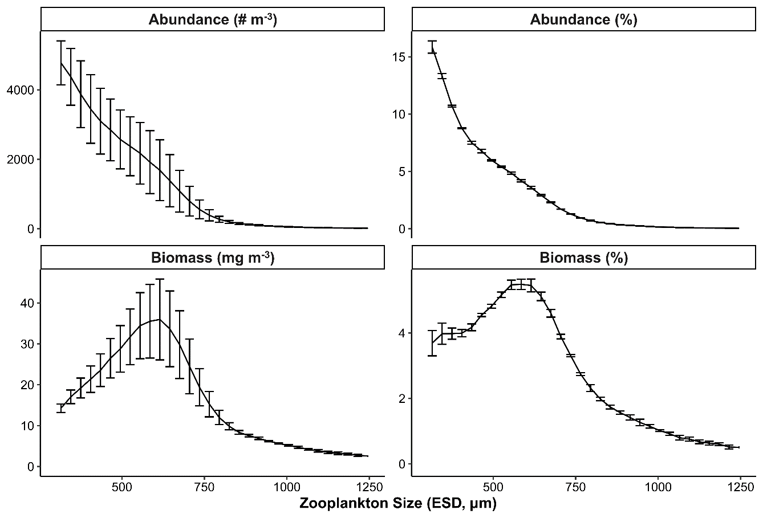**Fig 1**. Mean zooplankton size structure in the lower Sydney Harbour during our study. Error bars show 1 standard error.



**Fig. 2.** a) Average number of identifiable individuals for each prey type per gut (+ standard error). Note the log10 scale on the y-axis. b) Frequency occurrence (%) of each prey type, which shows the percentage of fish guts that contained at least one identifiable individual of the prey type

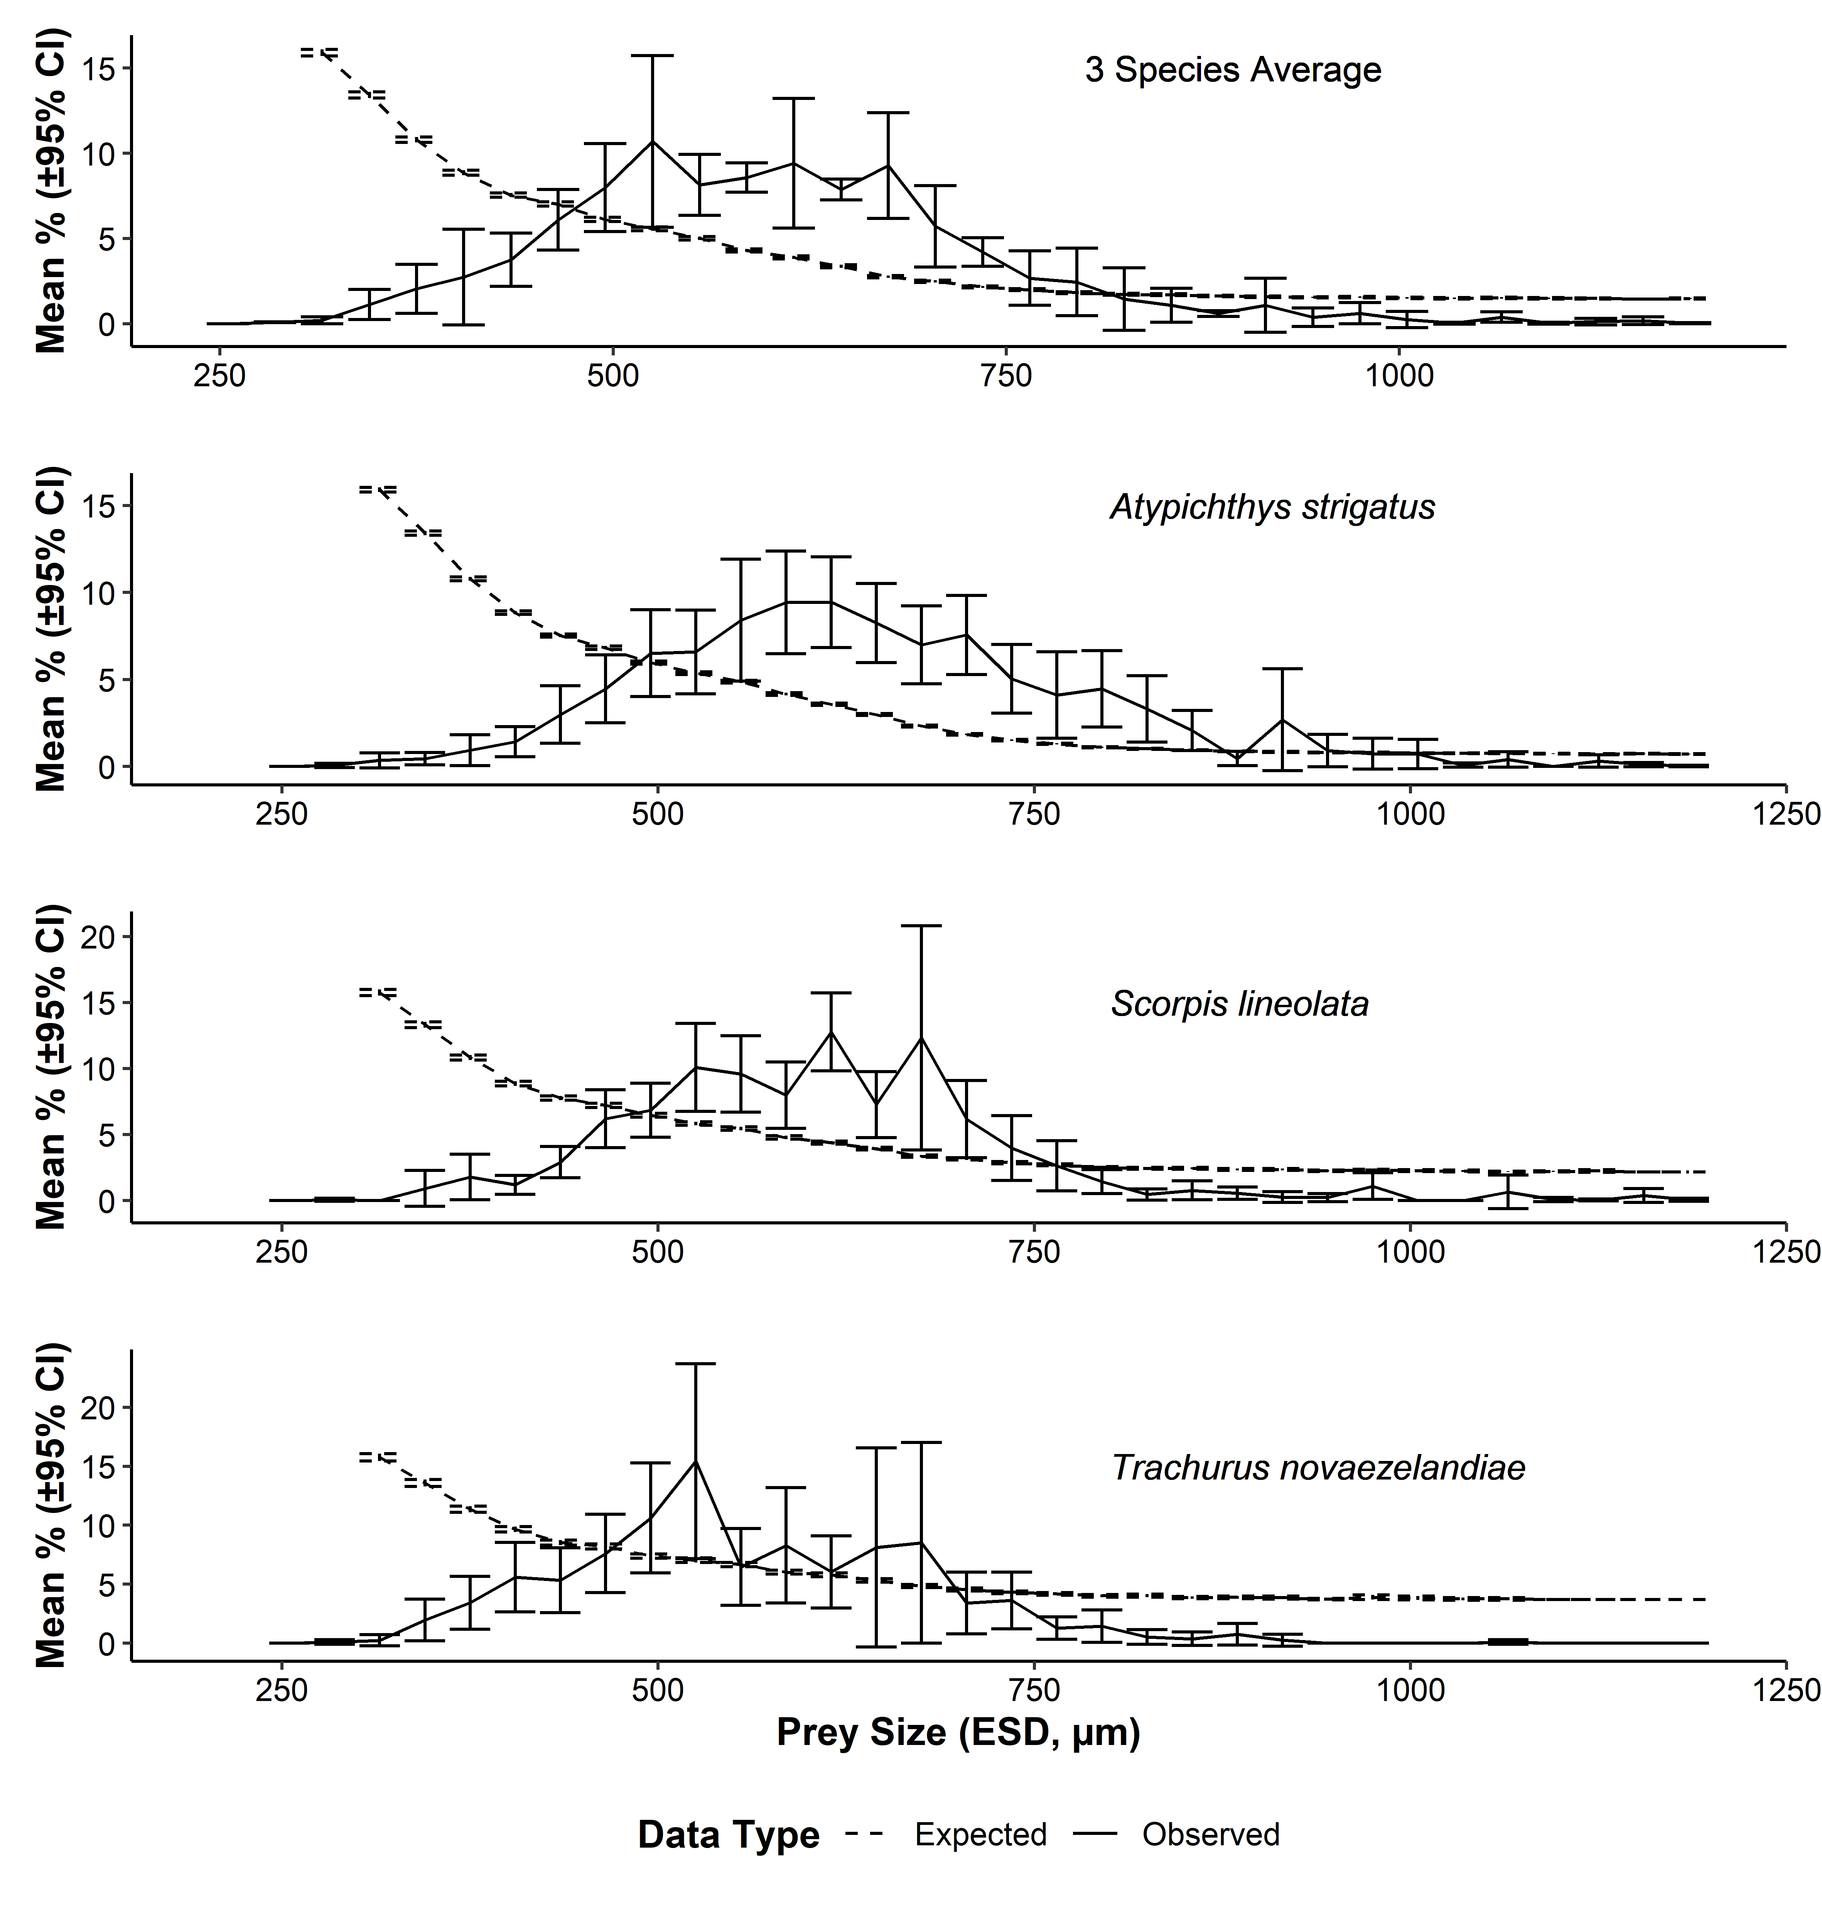

**Fig 3**. Comparison of observed zooplankton fish prey size (solid line) and the expected prey size distribution (dashed line) based upon abundance of different zooplankton size classes in the environment for A) the average of 3 species, B) *Atypichthys strigatus*, C) *Scorpis lineolate*, and D) *Trachurus novaezelandiae*. Error bars show 95% Confidence Intervals around the mean. Size classes greater than 1200 µm ESD are not displayed because they contained few prey items (less than 0.02% total).

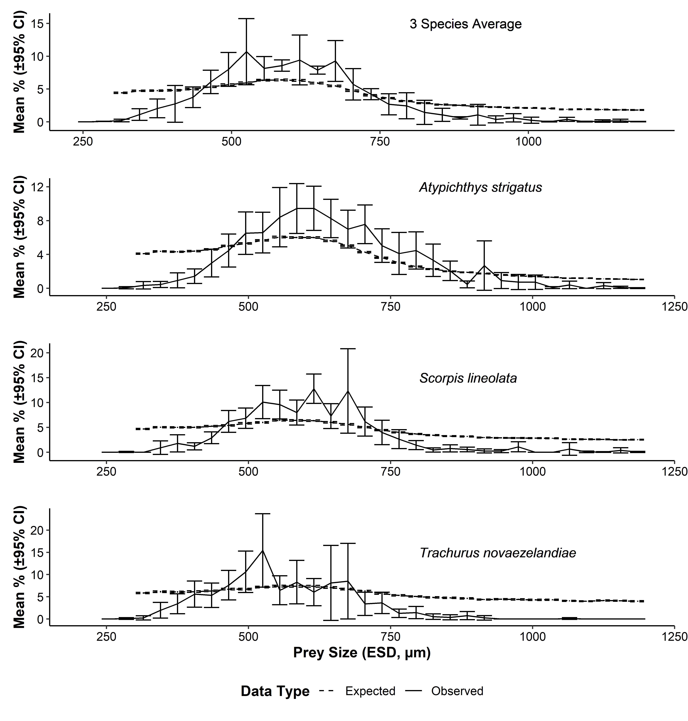

**Fig 4**. Comparison of observed zooplankton fish prey size (solid line) and the expected prey size distribution (dashed line) based upon total biomass of different zooplankton size classes in the environment for A) the average of 3 species, B) *Atypichthys strigatus*, C) *Scorpis lineolate*, and D) *Trachurus novaezelandiae*. Error bars show 95% Confidence Intervals around the mean. Size classes greater than 1200 µm ESD are not displayed because they contained few prey items (less than 0.02% total).

**References**

Andersen KH, Berge T, Gonçalves RJ, Hartvig M, Heuschele J, Hylander S, Jacobsen NS, Lindemann C, Martens EA, Neuheimer AB, Olsson K, Palacz A, Prowe AEF, Sainmont J, Traving SJ, Visser AW, Wadhwa N, Kiørboe T (2016) ‘Characteristic Sizes of Life in the Oceans, from Bacteria to Whales’ *Annual Review of Marine Science* **8**, 217–241. doi:10.1146/annurev-marine-122414-034144

Andersen KH, Beyer JE (2006) ‘Asymptotic Size Determines Species Abundance in the Marine Size Spectrum.’ *The American Naturalist* **168**, 54–61. doi:10.1086/504849

Barnardo T, Tambling CJ, Davies AB, Klein-Snakenborg S, Asner GP, le Roux E, Cromsigt JPGM, Druce DJ, Kerley GIH (2020) ‘Opportunistic feeding by lions: non-preferred prey comprise an important part of lion diets in a habitat where preferred prey are abundant’ *Mammal Research* **65**, 235–243. doi:10.1007/s13364-020-00481-3

Blanchard JL, Andersen KH, Scott F, Hintzen NT, Piet G, Jennings S (2014) ‘Evaluating targets and trade-offs among fisheries and conservation objectives using a multispecies size spectrum model’ *Journal of Applied Ecology* **51**, 612–622. doi:10.1111/1365-2664.12238

Blanchard JL, Heneghan RF, Everett JD, Trebilco R, Richardson AJ (2017) ‘From Bacteria to Whales: Using Functional Size Spectra to Model Marine Ecosystems’ *Trends in Ecology & Evolution* **32**, 174–186. doi:10.1016/j.tree.2016.12.003

Budy P, Haddix T, Schneidervin R (2005) ‘Zooplankton Size Selection Relative to Gill Raker Spacing in Rainbow Trout’ *Transactions of the American Fisheries Society* **134**, 1228–1235. doi:10.1577/T04-159.1

Bulman C, Althaus F, He X, Bax NJ, Williams A (2001) ‘Diets and trophic guilds of demersal fishes of the south-eastern Australian shelf’ *Marine and Freshwater Research* **52**, 537–548. doi:10.1071/mf99152

Champion C, Suthers IM, Smith JA (2015) ‘Zooplanktivory is a key process for fish production on a coastal artificial reef’ *Mar Ecol-Prog Ser* **541**, 1–14. doi:10.3354/meps11529

Chappell BF, Smith KG (2016) ‘Patterns of predation of native reef fish by invasive Indo-Pacific lionfish in the western Atlantic: Evidence of selectivity by a generalist predator’ *Global Ecology and Conservation* **8**, 18–23. doi:10.1016/j.gecco.2016.08.002

Chesson J (1978) ‘Measuring Preference in Selective Predation’ *Ecology* **59**, 211–215. doi:10.2307/1936364

Chisholm LA, Roff JC (1990) ‘Size-weight relationships and biomass of tropical neritic copepods off Kingston, Jamaica’ *Marine Biology* **106**, 71–77. doi:10.1007/BF02114676

Das P, Marchesiello P, Middleton JH (2000) ‘Numerical modelling of tide-induced residual circulation in Sydney Harbour’ *Marine and Freshwater Research* **51**, 97–112. doi:10.1071/mf97177

Dawson G, Suthers IM, Brodie S, Smith JA (2020) ‘The bioenergetics of a coastal forage fish: Importance of empirical values for ecosystem models’ *Deep Sea Research Part II: Topical Studies in Oceanography* **175**, 104700. doi:10.1016/j.dsr2.2019.104700

Edgar GJ, Stuart-Smith RD (2014) ‘Systematic global assessment of reef fish communities by the Reef Life Survey program’ *Scientific Data* **1**, 140007. doi:10.1038/sdata.2014.7

Foo D, Semmens JM, Arnould JPY, Dorville N, Hoskins AJ, Abernathy K, Marshall GJ, Hindell MA (2016) ‘Testing optimal foraging theory models on benthic divers’ *Animal Behaviour* **112**, 127–138. doi:10.1016/j.anbehav.2015.11.028

Gardner MB (1981) ‘Mechanisms of Size Selectivity by Planktivorous Fish: A Test of Hypotheses’ *Ecology* **62**, 571–578. doi:10.2307/1937723

Glasby TM, Kingsford MJ (1994) ‘*Atypichthys strigatus* (Pisces: Scorpididae): An opportunistic planktivore that responds to benthic disturbances and cleans other fishes’ *Australian Journal of Ecology* **19**, 385–394. doi:10.1111/j.1442-9993.1994.tb00504.x

Hansen AG, Beauchamp DA, Schoen ER (2013) ‘Visual Prey Detection Responses of Piscivorous Trout and Salmon: Effects of Light, Turbidity, and Prey Size’ *Transactions of the American Fisheries Society* **142**, 854–867. doi:10.1080/00028487.2013.785978

Hatton IA, Heneghan RF, Bar-On YM, Galbraith ED (2021) ‘The global ocean size spectrum from bacteria to whales’ *Science Advances* **7**, eabh3732. doi:10.1126/sciadv.abh3732

Heneghan RF, Everett JD, Blanchard JL, Richardson AJ (2016) ‘Zooplankton Are Not Fish: Improving Zooplankton Realism in Size-Spectrum Models Mediates Energy Transfer in Food Webs’ *Frontiers in Marine Science* **3**,. doi:10.3389/fmars.2016.00201

Herman AW, Beanlands B, Phillips EF (2004) ‘The next generation of Optical Plankton Counter: the Laser-OPC’ *Journal of Plankton Research* **26**, 1135–1145. doi:10.1093/plankt/fbh095

Hernández-Pliego J, Rodríguez C, Dell’Omo G, Bustamante J (2017) ‘Combined use of tri-axial accelerometers and GPS reveals the flexible foraging strategy of a bird in relation to weather conditions’ *PLOS ONE* **12**, e0177892. doi:10.1371/journal.pone.0177892

Jansen T, Post S, Olafsdottir AH, Reynisson P, Óskarsson GJ, Arendt KE (2019) ‘Diel vertical feeding behaviour of Atlantic mackerel (*Scomber scombrus*) in the Irminger current’ *Fisheries Research* **214**, 25–34. doi:10.1016/j.fishres.2019.01.020

Johnston EL, Mayer-Pinto M, Hutchings PA, Marzinelli EM, Ahyong ST, Birch G, Booth DJ, Creese RG, Doblin MA, Figueira W, Gribben PE, Pritchard T, Roughan M, Steinberg PD, Hedge LH (2015) ‘Sydney Harbour: what we do and do not know about a highly diverse estuary’ *Marine and Freshwater Research* **66**, 1073–1087. doi:10.1071/MF15159

Kingsford MJ (1989) ‘Distribution patters of planktivorous reef fish along the coast of northeastern New Zealand’ *Marine Ecology Progress Series* **54**, 13–24.

Langeland A, Nøst T (1995) ‘Gill raker structure and selective predation on zooplankton by particulate feeding fish’ *Journal of Fish Biology* **47**, 719–732. doi:10.1111/j.1095-8649.1995.tb01937.x

Moore SK, Suthers IM (2006) ‘Evaluation and correction of subresolved particles by the optical plankton counter in three Australian estuaries with pristine to highly modified catchments’ *Journal of Geophysical Research: Oceans* **111**,. doi:10.1029/2005jc002920

Pierce GJ, Ollason JG (1987) ‘Eight Reasons Why Optimal Foraging Theory Is a Complete Waste of Time’ *Oikos* **49**, 111–118. doi:10.2307/3565560

Pikitch EK, Rountos KJ, Essington TE, Santora C, Pauly D, Watson R, Sumaila UR, Boersma PD, Boyd IL, Conover DO, Cury P, Heppell SS, Houde ED, Mangel M, Plagányi É, Sainsbury K, Steneck RS, Geers TM, Gownaris N, Munch SB (2014) ‘The global contribution of forage fish to marine fisheries and ecosystems’ *Fish and Fisheries* **15**, 43–64. doi:10.1111/faf.12004

Pyke GH, Pulliam HR, Charnov EL (1977) ‘Optimal Foraging: A Selective Review of Theory and Tests’ *The Quarterly Review of Biology* **52**, 137–154. doi:10.1086/409852

R Core Team (2020) ‘R: A Language and Environment for Statistical Computing v4.0.2.’ (R Foundation for Statistical Computing: Vienna, Austria)

Schneider CA, Rasband WS, Eliceiri KW (2012) ‘NIH Image to ImageJ: 25 years of image analysis’ *Nature Methods* **9**, 671–675. doi:10.1038/nmeth.2089

Sheldon RW, Prakash A, Sutcliffe WH (1972) ‘The Size Distribution of Particles in the Ocean’ *Limnology and Oceanography* **17**, 327–340. doi:10.4319/lo.1972.17.3.0327

Suthers IM, Taggart CT, Kelley D, Rissik D, Middleton JH (2004) ‘Entrainment and advection in an island’s tidal wake, as revealed by light attenuance, zooplankton, and ichthyoplankton’ *Limnology and Oceanography* **49**, 283–296. doi:10.4319/lo.2004.49.1.0283

Tanaka H, Aoki I, Ohshimo S (2006) ‘Feeding habits and gill raker morphology of three planktivorous pelagic fish species off the coast of northern and western Kyushu in summer’ *Journal of Fish Biology* **68**, 1041–1061. doi:10.1111/j.0022-1112.2006.00988.x

Thygesen UH, Sommer L, Evans K, Patterson TA (2016) ‘Dynamic optimal foraging theory explains vertical migrations of Bigeye tuna’ *Ecology* **97**, 1852–1861. doi:10.1890/15-1130.1

Truong L, Suthers IM, Cruz DO, Smith JA (2017) ‘Plankton supports the majority of fish biomass on temperate rocky reefs’ *Marine Biology* **164**, 12. doi:10.1007/s00227-017-3101-5

Tyson RB, Friedlaender AS, Nowacek DP (2016) ‘Does optimal foraging theory predict the foraging performance of a large air-breathing marine predator?’ *Animal Behaviour* **116**, 223–235. doi:10.1016/j.anbehav.2016.03.034

Wanzenbock J (1995) ‘Changing handling times during feeding and consequences for prey size selection of O+ zooplanktivorousfish’ *Oecologia* 7.

**Supplementary Material**

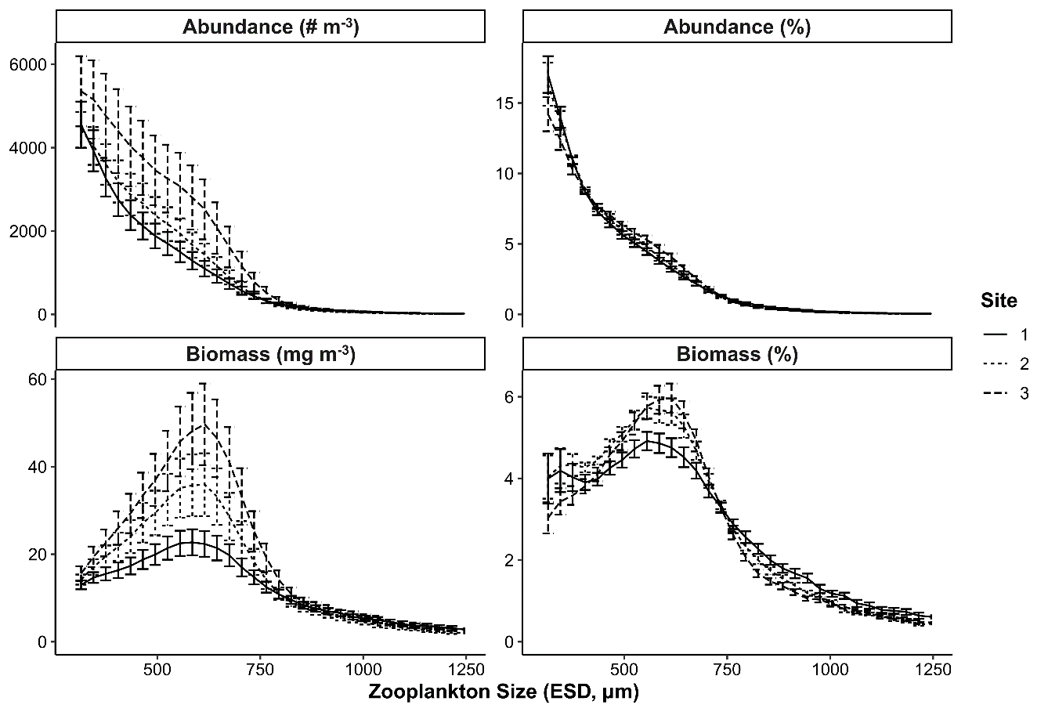

**Fig S1. Z**ooplankton size structure at the three sampled sites in the lower Sydney Harbour during our study. Error bars show 1 standard error.

**Table S1** Summary of the prey selectivity for all three species combined and individually. Observed diet percentage was calculated based the abundance of each size classes observed in hut contents. The expected proportion of each size class based upon abundance and biomass was determined through a simulation based upon the observed abundances and biomasses in each size class in the environment. The provided P-values are conservative estimates based upon the proportion of times in the simulations (n = 2000) that the expected percentage fell within the 95% confidence interval of the mean observed data.

| **Species** | **Size Class** | **Mean Observed Percentage in diet** | **SE of Observed Percentage** | **Mean Expected Proportion based upon abundance** | **P-value** | **Mean Expected Proportion based upon biomass** | **P-value** |
| --- | --- | --- | --- | --- | --- | --- | --- |
| **Average of 3 species** | 315 | 0.198 | 0.104 | 15.914 | 0.000 | 4.415 | 0.000 |
| 345 | 1.112 | 0.451 | 13.418 | 0.001 | 4.727 | 0.000 |
| 375 | 2.048 | 0.732 | 10.794 | 0.016 | 4.748 | 0.000 |
| 405 | 2.738 | 1.431 | 8.854 | 0.127 | 4.804 | 0.010 |
| 435 | 3.745 | 0.800 | 7.545 | 0.201 | 4.990 | 0.021 |
| 465 | 6.088 | 0.909 | 7.024 | 0.528 | 5.345 | 0.118 |
| 495 | 7.993 | 1.316 | 6.113 | 0.547 | 5.664 | 0.318 |
| 525 | 10.698 | 2.571 | 5.557 | 0.525 | 5.946 | 0.817 |
| 555 | 8.154 | 0.914 | 5.011 | 0.195 | 6.350 | 0.234 |
| 585 | 8.568 | 0.440 | 4.294 | 0.037 | 6.382 | 0.248 |
| 615 | 9.424 | 1.943 | 3.883 | 0.233 | 6.313 | 0.230 |
| 645 | 7.878 | 0.308 | 3.364 | 0.000 | 5.902 | 0.050 |
| 675 | 9.278 | 1.587 | 2.754 | 0.019 | 5.473 | 0.019 |
| 705 | 5.714 | 1.218 | 2.480 | 0.116 | 4.744 | 0.028 |
| 735 | 4.212 | 0.427 | 2.159 | 0.038 | 4.048 | 0.012 |
| 765 | 2.674 | 0.817 | 1.986 | 0.456 | 3.608 | 0.142 |
| 795 | 2.442 | 1.011 | 1.819 | 0.389 | 3.154 | 0.088 |
| 825 | 1.435 | 0.939 | 1.722 | 0.298 | 2.855 | 0.303 |
| 855 | 1.073 | 0.508 | 1.697 | 0.202 | 2.624 | 0.237 |
| 885 | 0.592 | 0.091 | 1.625 | 0.000 | 2.531 | 0.194 |
| 915 | 1.069 | 0.809 | 1.584 | 0.158 | 2.351 | 0.173 |
| 945 | 0.379 | 0.274 | 1.543 | 0.000 | 2.251 | 0.145 |
| 975 | 0.609 | 0.320 | 1.548 | 0.000 | 2.152 | 0.131 |
| 1005 | 0.240 | 0.240 | 1.513 | 0.000 | 2.114 | 0.098 |
| 1035 | 0.027 | 0.027 | 1.485 | 0.000 | 2.040 | 0.000 |
| 1065 | 0.384 | 0.157 | 1.511 | 0.000 | 1.889 | 0.067 |
| 1095 | 0.027 | 0.027 | 1.494 | 0.000 | 1.922 | 0.000 |
| 1125 | 0.116 | 0.097 | 1.478 | 0.000 | 1.864 | 0.000 |
| 1155 | 0.166 | 0.115 | 1.449 | 0.000 | 1.826 | 0.050 |
| 1185 | 0.029 | 0.018 | 1.466 | 0.000 | 1.799 | 0.000 |
| **Mado** | 315 | 0.351 | 0.223 | 15.910 | 0.000 | 4.089 | 0.013 |
| 345 | 0.447 | 0.183 | 13.417 | 0.000 | 4.365 | 0.008 |
| 375 | 0.936 | 0.453 | 10.776 | 0.000 | 4.315 | 0.053 |
| 405 | 1.431 | 0.440 | 8.840 | 0.001 | 4.393 | 0.108 |
| 435 | 2.986 | 0.840 | 7.523 | 0.068 | 4.603 | 0.487 |
| 465 | 4.461 | 0.995 | 6.825 | 0.450 | 5.015 | 0.758 |
| 495 | 6.514 | 1.276 | 5.967 | 0.817 | 5.304 | 0.763 |
| 525 | 6.584 | 1.230 | 5.369 | 0.651 | 5.664 | 0.687 |
| 555 | 8.405 | 1.790 | 4.877 | 0.415 | 6.060 | 0.662 |
| 585 | 9.429 | 1.503 | 4.158 | 0.087 | 6.003 | 0.373 |
| 615 | 9.453 | 1.330 | 3.572 | 0.033 | 5.999 | 0.364 |
| 645 | 8.246 | 1.158 | 2.983 | 0.029 | 5.605 | 0.409 |
| 675 | 6.994 | 1.141 | 2.325 | 0.050 | 5.049 | 0.586 |
| 705 | 7.559 | 1.164 | 1.840 | 0.002 | 4.269 | 0.283 |
| 735 | 5.043 | 1.010 | 1.516 | 0.043 | 3.612 | 0.594 |
| 765 | 4.113 | 1.265 | 1.294 | 0.176 | 3.022 | 0.793 |
| 795 | 4.464 | 1.123 | 1.106 | 0.020 | 2.570 | 0.486 |
| 825 | 3.312 | 0.976 | 1.014 | 0.049 | 2.272 | 0.601 |
| 855 | 2.063 | 0.591 | 0.938 | 0.135 | 2.004 | 0.609 |
| 885 | 0.458 | 0.205 | 0.872 | 0.317 | 1.885 | 0.204 |
| 915 | 2.687 | 1.492 | 0.836 | 0.348 | 1.740 | 0.906 |
| 945 | 0.912 | 0.478 | 0.811 | 0.283 | 1.579 | 0.540 |
| 975 | 0.741 | 0.453 | 0.803 | 0.234 | 1.479 | 0.583 |
| 1005 | 0.719 | 0.433 | 0.754 | 0.208 | 1.400 | 0.570 |
| 1035 | 0.081 | 0.058 | 0.758 | 0.000 | 1.303 | 0.000 |
| 1065 | 0.397 | 0.228 | 0.755 | 0.120 | 1.193 | 0.351 |
| 1095 | 0.000 | 0.000 | 0.740 | 0.000 | 1.196 | 0.000 |
| 1125 | 0.309 | 0.182 | 0.716 | 0.000 | 1.108 | 0.000 |
| 1155 | 0.112 | 0.062 | 0.731 | 0.000 | 1.091 | 0.000 |
| 1185 | 0.026 | 0.026 | 0.710 | 0.000 | 1.044 | 0.000 |
| **Sweep** | 315 | 0.000 | 0.000 | 15.747 | 0.000 | 4.681 | 0.000 |
| 345 | 0.917 | 0.690 | 13.315 | 0.011 | 5.026 | 0.267 |
| 375 | 1.778 | 0.881 | 10.835 | 0.027 | 5.007 | 0.251 |
| 405 | 1.186 | 0.368 | 8.867 | 0.000 | 5.011 | 0.000 |
| 435 | 2.905 | 0.604 | 7.770 | 0.091 | 5.238 | 0.246 |
| 465 | 6.200 | 1.118 | 7.211 | 0.440 | 5.399 | 0.477 |
| 495 | 6.846 | 1.040 | 6.463 | 0.382 | 5.811 | 0.366 |
| 525 | 10.083 | 1.702 | 5.830 | 0.226 | 6.003 | 0.240 |
| 555 | 9.598 | 1.474 | 5.464 | 0.176 | 6.424 | 0.242 |
| 585 | 7.981 | 1.283 | 4.776 | 0.240 | 6.411 | 0.394 |
| 615 | 12.774 | 1.512 | 4.388 | 0.021 | 6.343 | 0.130 |
| 645 | 7.265 | 1.268 | 3.928 | 0.137 | 6.016 | 0.354 |
| 675 | 12.328 | 4.333 | 3.353 | 0.267 | 5.613 | 0.692 |
| 705 | 6.171 | 1.491 | 3.158 | 0.189 | 5.038 | 0.565 |
| 735 | 3.971 | 1.254 | 2.865 | 0.428 | 4.453 | 0.584 |
| 765 | 2.626 | 0.972 | 2.700 | 0.351 | 3.998 | 0.603 |
| 795 | 1.428 | 0.458 | 2.509 | 0.238 | 3.675 | 0.365 |
| 825 | 0.458 | 0.214 | 2.440 | 0.000 | 3.432 | 0.000 |
| 855 | 0.775 | 0.371 | 2.445 | 0.000 | 3.247 | 0.000 |
| 885 | 0.553 | 0.242 | 2.360 | 0.000 | 3.178 | 0.000 |
| 915 | 0.263 | 0.202 | 2.350 | 0.000 | 2.951 | 0.000 |
| 945 | 0.224 | 0.161 | 2.254 | 0.000 | 2.881 | 0.000 |
| 975 | 1.086 | 0.513 | 2.299 | 0.000 | 2.868 | 0.000 |
| 1005 | 0.000 | 0.000 | 2.265 | 0.000 | 2.830 | 0.000 |
| 1035 | 0.000 | 0.000 | 2.236 | 0.000 | 2.816 | 0.000 |
| 1065 | 0.649 | 0.649 | 2.195 | 0.000 | 2.604 | 0.000 |
| 1095 | 0.081 | 0.081 | 2.199 | 0.000 | 2.607 | 0.000 |
| 1125 | 0.041 | 0.041 | 2.242 | 0.000 | 2.587 | 0.000 |
| 1155 | 0.387 | 0.267 | 2.174 | 0.000 | 2.481 | 0.000 |
| 1185 | 0.061 | 0.061 | 2.174 | 0.000 | 2.523 | 0.000 |
| **Yakka** | 315 | 0.244 | 0.244 | 15.760 | 0.000 | 5.856 | 0.000 |
| 345 | 1.973 | 0.894 | 13.580 | 0.091 | 6.139 | 0.371 |
| 375 | 3.429 | 1.142 | 11.349 | 0.147 | 6.091 | 0.366 |
| 405 | 5.597 | 1.500 | 9.644 | 0.483 | 6.172 | 0.602 |
| 435 | 5.345 | 1.397 | 8.527 | 0.552 | 6.314 | 0.609 |
| 465 | 7.603 | 1.695 | 8.202 | 0.287 | 6.722 | 0.240 |
| 495 | 10.619 | 2.385 | 7.387 | 0.464 | 6.717 | 0.401 |
| 525 | 15.427 | 4.210 | 7.036 | 0.444 | 7.188 | 0.456 |
| 555 | 6.461 | 1.658 | 6.673 | 0.613 | 7.403 | 0.593 |
| 585 | 8.295 | 2.497 | 6.013 | 0.652 | 7.364 | 0.731 |
| 615 | 6.045 | 1.555 | 5.805 | 0.552 | 7.360 | 0.601 |
| 645 | 8.123 | 4.304 | 5.308 | 0.567 | 7.084 | 0.780 |
| 675 | 8.514 | 4.337 | 4.839 | 0.460 | 6.713 | 0.737 |
| 705 | 3.413 | 1.333 | 4.556 | 0.284 | 6.272 | 0.355 |
| 735 | 3.623 | 1.219 | 4.310 | 0.246 | 5.744 | 0.360 |
| 765 | 1.283 | 0.484 | 4.179 | 0.000 | 5.317 | 0.000 |
| 795 | 1.434 | 0.701 | 4.018 | 0.000 | 5.075 | 0.000 |
| 825 | 0.536 | 0.314 | 4.030 | 0.000 | 4.861 | 0.000 |
| 855 | 0.381 | 0.288 | 3.854 | 0.000 | 4.755 | 0.000 |
| 885 | 0.765 | 0.464 | 3.896 | 0.000 | 4.630 | 0.000 |
| 915 | 0.256 | 0.256 | 3.868 | 0.000 | 4.384 | 0.000 |
| 945 | 0.000 | 0.000 | 3.736 | 0.000 | 4.450 | 0.000 |
| 975 | 0.000 | 0.000 | 3.897 | 0.000 | 4.399 | 0.000 |
| 1005 | 0.000 | 0.000 | 3.825 | 0.000 | 4.308 | 0.000 |
| 1035 | 0.000 | 0.000 | 3.762 | 0.000 | 4.333 | 0.000 |
| 1065 | 0.106 | 0.106 | 3.760 | 0.000 | 4.085 | 0.000 |
| 1095 | 0.000 | 0.000 | 3.704 | 0.000 | 3.995 | 0.000 |
| 1125 | 0.000 | 0.000 | 3.704 | 0.000 | 4.159 | 0.000 |
| 1155 | 0.000 | 0.000 | 3.704 | 0.000 | 4.110 | 0.000 |
| 1185 | 0.000 | 0.000 | 3.704 | 0.000 | 3.996 | 0.000 |